

**SYLLABUS CONTENT**

**INSTRUCTORS: Below is content to copy and paste into your syllabus pertaining to the SociologicalYOU textbook.**

**COURSE DESCRIPTION**:

Thank you choosing my course and **WELCOME!** I look forward to introducing you to the discipline of sociology. This course provides you an understanding of how we view society from a systematic and scientific perspective. My goal is to help you apply the sociological concepts to your everyday life allowing you to better understand the complex world you live in. The various theories and methods of investigating the subject matter of sociology will be introduced at a fundamental level. In this introduction, you will be exposed to basic sociological concepts, theoretical perspectives, methods of research, and research findings. The range of concepts discussed will span the continuum from individual roles to global social structures. This grounding in the foundations of sociology should enable you to see more clearly the variety of interesting and important social causes, patterns, issues, and implications in the world in which you live. You are challenged to apply the information you learn in each session so that the course is applicable to your life. Sociology is rich in applications and has the ability to make a difference in your day-to-day life. Simply stated, the goal of this course is **“Connecting Sociology and YOU!”**

**COURSE LEARNING OUTCOMES**:

1. Demonstrate knowledge of sociological vocabulary, concepts, history, theories, and theorists.
2. Compare and contrast the sociological characteristics of diverse cultures and societies in the United States and the world.
3. Analyze social and economic inequalities in the world.
4. Apply a sociological perspective to making informed decisions about everyday life and opportunities.
5. Provide examples of how members of society are molded and shaped by the agents of socialization.

**TEXTBOOK**The digital textbook for this course is **SociologicalYOU**, (ISBN: 978-1-64007-406-4) and written by Angela Thompson, Ph.D. and Keith Whitworth, Ph.D. The textbook can be purchased directly online at <http://www.SociologicalYOU.com> via a credit card or by purchasing an access code at the campus bookstore or an online distributor.

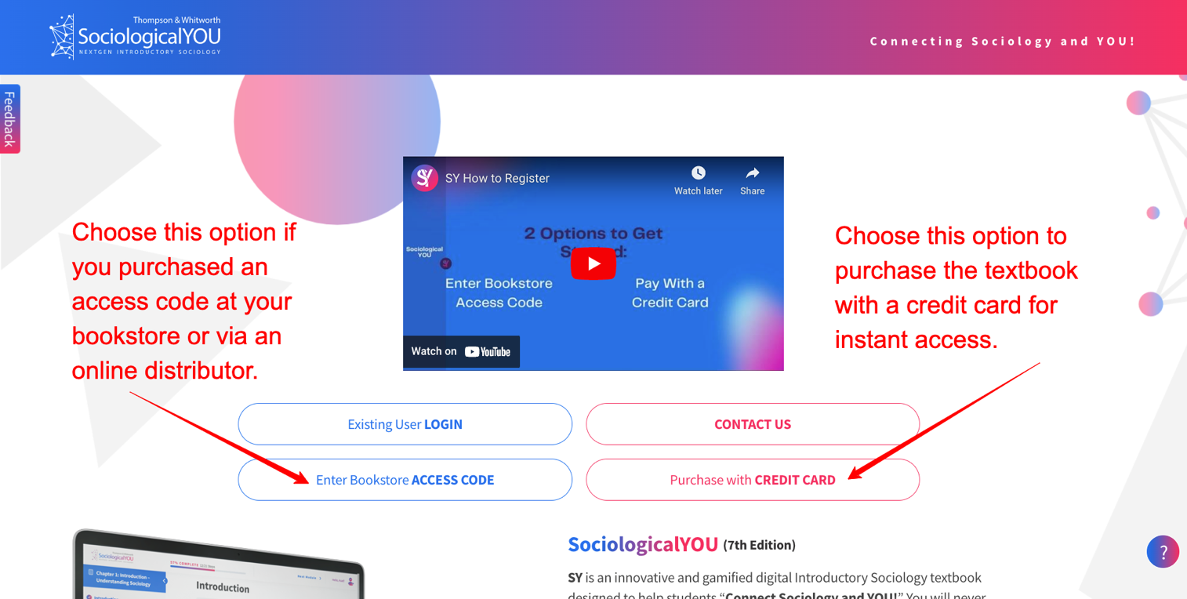

**TEXTBOOK CITATION**  
The textbook citation below is within the American Sociological Association (ASA) format.  
  
Thompson, Angela, and Keith Whitworth. 2023. SociologicalYOU: Introductory Sociology. Hudson Oaks: UITAC Publishing.

**SociologicalYOU CHAPTERS**

1. Understanding Sociology
2. Sociological Inquiry
3. Culture
4. Socialization
5. Social Interaction
6. Groups and Organization
7. Crime and Deviance
8. Social Stratification
9. Sex and Gender
10. Race and Ethnicity
11. Economics and Politics
12. Religion and Education
13. Marriage and Family
14. Health, Illness, and Medicine
15. Social Change and Social Movements

**SociologicalYOU GAMIFICATION**Your textbook is gamified to make learning fun and effective. Each chapter has 7 activities to complete to earn points and badges to unlock bonus content. Each of the 7 activities takes 2-4 minutes to complete. Based on the points you accumulate in each chapter, you can unlock a full-length practice exam, a study guide with answers, and an animated chapter summary video. You can view your points, badges, and bonuses by selecting “**My Badges and Bonuses**” within your profile at the top right corner of every page in the textbook.   
  
The textbook will introduce you to **SYlvia** and **SYlvester**, who serve as your guides and encouragers throughout the textbook. These fun characters will walk you through the gamification features.

The **Science of Learning, Achievement and Happiness videos** is an innovative aspect of the gamification feature. These 15 videos are approximately 3-4 minutes long and are designed to introduce you to what science says about learning, achievement, and happiness. The videos can be transformational and help you **THRIVE** personally and academically to optimize your studying to reach your goals in this course. 

**SociologicalYOU CHAPTER COMPLETION CERTIFICATES**  
  
Each chapter in your textbook is divided into 5 modules.

* The Sociological Perspective
* Social Structure
* Social Problems
* The Sociological Imagination
* Social Change

At the end of each learning objective within the modules, there are low-stake quizzes for you to complete. You can answer the questions as many times as needed to score a 100%. This concept is called “*Read a little, do a little.”* The quizzes help check your reading comprehension. Upon completing all of the quizzes in the chapter and scoring a 100%, you will receive a digital chapter completion certificate (with confetti). Here is a sample certificate.

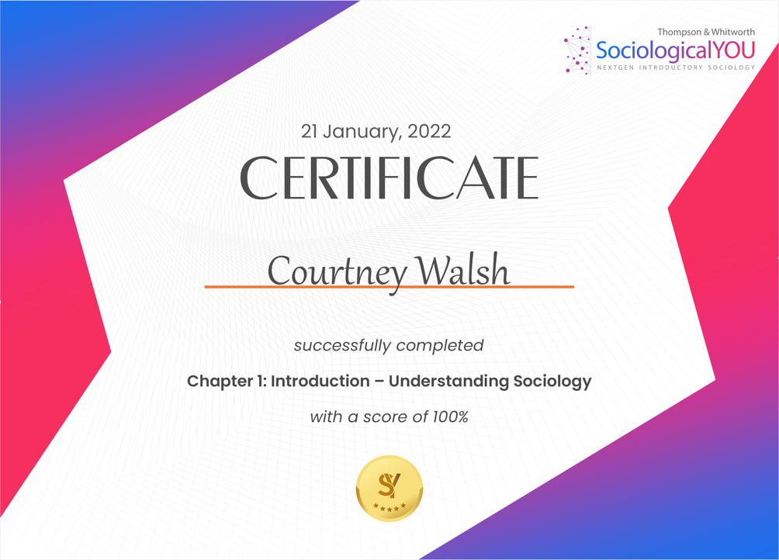

**SociologicalYOU STUDENT RESOURCES**

Your textbook provides tremendous resources to help you succeed in the course. You can access these resources by selecting your profile in the top right corner of every page in the textbook. Select “**My Resources**” from the profile dropdown menu to view the resources specific to each chapter.

**SociologicalYOU SUPPORT**

If you have any issues or questions about accessing or using the textbook and features, contact [Support@SociologicalYOU.com](mailto:Support@SociologicalYOU.com). The help desk typically responds within hours during the day and by the next morning if you submit a support ticket in the evening.