Chapter 5 Social Interaction

Study Guide Answers
While not everything may be in this study guide, it will help you review some key points in each chapter module. Read through the module, expanded key terms, and ask your instructor if there are additional questions after completing this study guide.

Module 1
- What are the three basic processes commonly present during social interaction?
  - Social context
  - Social construction of reality
  - Social attribution
- Why are social interactions complex?
  - There are many elements that are open for interpretation
    - Sometimes, we struggle to convey meaning and other times we fail to understand what others are trying to communicate to us
    - As we interact, we are developing our self-image and our view of reality based on our subjective feelings about the encounter and our interpretation of our performance
- Discuss Garfinkel’s breaching experiments.
  - Tic-Tac-Toe game
    - Garfinkel used students as experimenters and had 250 subjects. The experimenters were told to erase the subject’s mark and move it to another cell and then make the second move or place the “X” on one of the lines instead of the boxes. Garfinkel then observed how the subjects reacted to the breach of rules.
    - His results were as follows
      - The majority reacted strongly or demanded an explanation
      - The minority laughed and played along with the experimenters
    - Garfinkel concluded that the subjects who hung on to the rules to make sense of the situation became angry or frustrated. Those who played along and abandoned the rules remained relaxed. Whether or not the subjects could make sense of the breach of rules determined how they handled the situation.
    - His methodology focused on the methods and presumptions involved in social interactions. For a society to maintain social order, there must be some methods that are used to mutually construct orderly social interactions.
- Discuss a contemporary example of breaching.
Scenario | Norm Breach
Ordering food at a restaurant and asking for the salad to be delivered at the end of the meal. | In the U.S., the order of each course of your meal – there is a method of when to eat specific courses at a meal.
During class, you stare intensely at your professor for 30 minutes without diverting your gaze. | Appropriate eye contact. Eye contact communicates a variety of messages (confidence, flirtatious gestures, honesty). There is a method for how much eye contact is allowed.
At a coffee shop with many empty seats, you choose to sit at a table where there is already another person seated. You also play videos on your laptop through the speakers. | Personal space. Invaded their domain and most likely caused them to feel uncomfortable.  Laptop etiquette.

- Who founded symbolic interactionism?
  - George Herbert Mead
  - Herbert Blumer compiled Mead’s writings and further developed his ideas. Mead coined the term symbolic interaction.
- Discuss the stage and setting as related in Goffman’s dramaturgy.
  - You are an actor on the stage of life and move between the front and backstage. Your performance is important to you so you are keenly aware of the setting, audience, scripts, and costumes in order to manage the impressions of others. You play different roles based on the settings and change costumes frequently during your daily performances. When you “forget your lines” you will engage in face work to prevent embarrassment. You alter your social performance as needed, which results in more satisfying interactions.
- What is an example of a script that you follow in your everyday social interactions?
  - As a student, you walk into class and sit in your chair facing forward. You take notes and raise your hand if you have questions. You provide eye contact with the instructor. You do not interrupt the instructor by talking loudly about the weather with a classmate.
- Provide an example of how you participate in face work in your everyday social interactions.
  - Have you ever been in an embarrassing situation due to a social miscue or faux pas? If so, you have experienced the process of saving face. How did you recover from your poor performance? Did other participants attempt to help you recover by ignoring the miscue or laughing to minimize the uncomfortable situation?
- What region of the world is face work very important in relation to everyday social interactions?
  - In Asian countries, saving face is to be taken into account in most daily interactions. Giving face means taking actions that make others admire someone, This is unique to Asian countries and is a serious way of showing respect and deference. Making a public scene, such as arguing or shouting causes bystanders to lose dace as a result of embarrassment.
- Who founded social exchange theory? Who further developed the theory?
  - George Homans established the theory
  - Peter Blau, Richard Emerson, and Karen Cook further developed it
- How can social exchange theory be applied to relationships?
  - You can compare the benefits and costs of the relationship.
    - Benefits: feeling loved, and supported, having a trusted companion
    - Costs: arguing, monetary issues, not having enough time to devote to the relationship

Module 2
- How is social status socially constructed?
  - Status is often used in the context of an inferiority-superiority scale that is based on socially approved and defined characteristics and attributes.
  - Members of society determine who and what is considered to have low and high status.
- How are social status and the Mursi tribe in Ethiopia related?
  - Women in the Mursi tribe are viewed as having status in their culture since they choose to stretch their lips and ears with clay plates.
- Provide examples of conspicuous consumption in China. In the US.
  - Billionaires buy 24-carat gold-plated luxury sports car Infiniti G-37
  - Chauffeurs drive their Rolls-Royce
  - Status symbols such as Armani, Burberry, and Louis Vuitton
- How are conspicuous consumption and sustainability related?
  - Driving a hybrid car, purchasing organic and Fair-Trade products, and choosing eco-friendly destination vacations become not just a statement of personal values, but also that the individual can afford to purchase these often more expensive alternatives
- Discuss social roles that can produce role strain and role conflict.
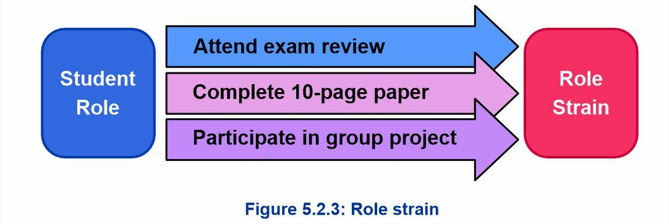
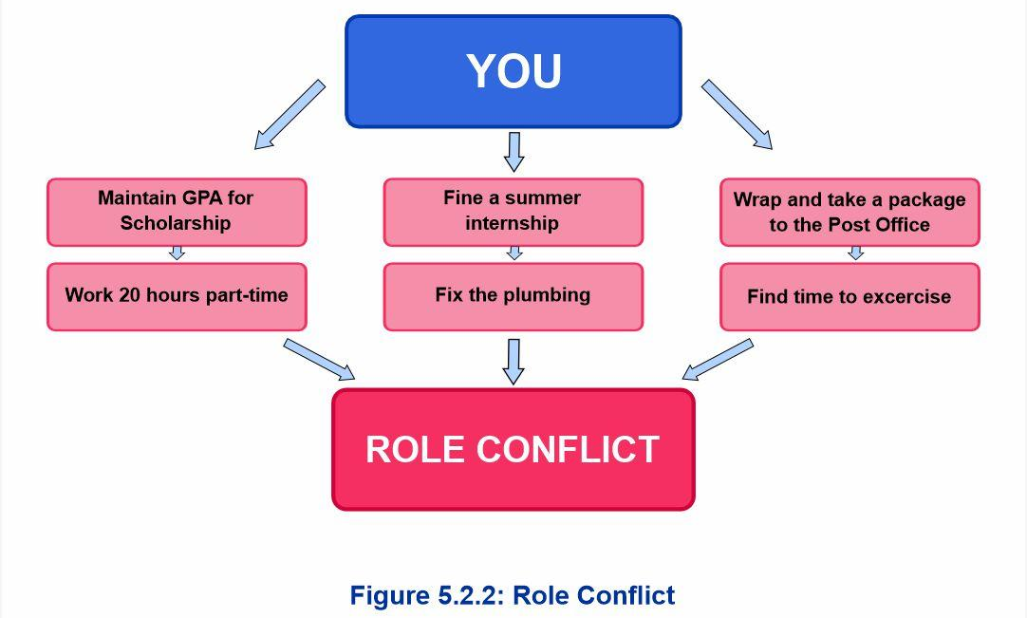
  - Example: A Car Salesperson
    - A car salesperson may feel the strain of striving to satisfy the customer, but at the same time feel pressure to please the sales manager by making as much profit as possible.
    - Role conflict involves multiple statuses such as being a part-time car salesperson, romantic partner, student, and a soccer coach.
- Discuss specific ways to cope with role strain and role conflict through the restructuring of roles.
  - Eliminate role activities but not entire roles
  - Seek role support from outside and inside the role set
  - Integrate roles by redesigning roles so that they can overlap and perform simultaneously in a mutually reinforced manner
  - Problem-solving with role senders to seek assistance in deciding how to redefine one’s roles
- List the four stages within role exiting.
  - Doubt Role Commitments
    - The individual questions and doubts their commitment to the organization. Members and outsiders pick up on these cues which further reinforces the discontentment
  - Seek Alternatives
    - The individual begins to discuss alternatives, especially with others who sympathize with their current role situation
    - Weighing the costs and rewards of exiting and identifying new groups to join
  - Turning Point
    - Actual exiting of the role
    - Reinforces that the old roles are undesirable and signals the need to begin creating new roles
  - Create an Ex-role
    - Requires shifting relationships, but also may include maintaining contact with members or ex-members
    - Role residual (hangover identity): the individual finds it difficult to shake off identification with previous roles
- Discuss re-entry programs as they relate to role exit.
  - Nearly 75% of ex-offenders come back into contact with the criminal justice system. Over 50% returned to prison from committing a new crime or violating the conditions of their release.
  - Upon exiting prison, individuals become labeled as ex-cons and that becomes their master status. Their social status is negatively impacted, their social roles are altered, they have difficulty finding employment, and rarely reveal their criminal background in conversations. This makes it difficult to create an ex-role and increases the probability of reoffending.

Module 3
- Provide an example of a social problem within the family, government, education, religion, and economics.
Table 5.3.1: Major Social Institutions and Their Problems
Social Institutions | Overview | Problems
Family | The family is a social institution that contributes greatly to society by socializing members, regulating sexual behavior, and creating a sense of belonging. Families accomplish this by rearing children, caring for the elderly, imparting norms and values, and passing culture from one generation to another. The family also passes along its social class position within society from one generation to the next. | Instability in the institution of the family may manifest as a rise in the rates of single parenting, divorce, and domestic violence in society. Problems in this social institution may result in families having difficulty regulating their members’ behavior and offering a stable foundation in which to raise children or care for the elderly in their time of need. The transmission of social class via the family contributes to social inequality and works to maintain stratification in the larger society.
Government | As a social institution, the government plays a key role in establishing order in society and regulating social behavior. Additionally, governments work to mediate disputes between parties within the society, plan, and establish the direction for the future, protect citizens, and maintain relations with other societies. | A breakdown in the institution of government can occur when leaders or agencies are unable or unwilling to fulfill their stated functions. This may result in citizens losing trust in the political process and their leaders. A lack of trust in the government regulations, and fear that the political agencies and leaders are not looking for citizens’ best interests. Extreme forms of government mistrust may result in citizens protesting and taking steps to overthrow the government.
Education | As a social institution, the education system is responsible for preparing youth for their role in society by transmitting knowledge, skills, and values. It also helps socialize and integrate people that have migrated from other societies. | Problems with education as a social institution may occur when the knowledge and skills it imparts to students do not mesh with society’s needs or properly prepare students to be productive members of society. Additionally, the disparity in educational standards works to reinforce social inequality because some students receive a better education than others and, as a result, are more prepared to advance in society.
Religion | Religion as a social institution is important to the socialization process because it helps indoctrinate citizens with values and beliefs. Typically, these values and beliefs are in line with the norms of the larger society. Religion works to comfort its members by providing answers to unanswerable life and death questions and by offering a sense of belonging, connectedness, or group unity. Religious institutions may also be instrumental in rallying members to take action around a particular social cause, as was the case with African American churches during the civil rights era. | As a social institution, religion has problems when its leaders act in ways that result in harm to its members or the larger society. Additionally, when religious institutions try to indoctrinate members with values and beliefs in opposition to the dominant culture, the result can be a confrontation with other members of society and law enforcement officials.
Economics | Economic institutions are instrumental in the distribution and regulation of financial resources in society. They are important to the manufacture of goods and services and fuel the creation of jobs. | Issues with economic institutions arise when the financial resources are concentrated in a few members of the society. In particular, the banking industry has been accused of catering to the needs of the wealthy while ignoring or misleading the middle class and the poor. Changes in economic institutions can have a ripple effect on society by impacting production and job creation in society.

Module 4
- Explain how the experience of airline personnel can be used to explain the sociological imagination.
  - Airline employees must use emotion labor. If they can’t manage their emotions, they might have a confrontation with a passenger.
- Describe types of harassment.
Table 5.4.2: Types of Harassment
Types of Harassment | Description
Sexual Harassment | Any welcome sexual conduct deemed offensive by the recipient. It can be verbal, physical, or sexual in nature.
Racial Harassment | Unwelcome verbal or physical behavior directed towards an individual(s) based on their race or national origin.
Personal Harassment | Bullying, rejecting, humiliating, intimidating, and uncivil conduct directed towards someone based on personal difference.
Sexual Orientation Harassment | Unwanted verbal, physical, and sexual conduct directed towards someone based on their sexual orientation.
Disability Harassment | Negative physical or verbal behavior directed towards an individual based on their mental or physical ability.
Age Harassment | Hurtful physical and verbal actions directed at a person based on their age.

Module 5
- What is the Thomas Theorem?
  - The idea that if we think something is real, then it is indeed real to us
- Explain how the Thomas Theorem can be useful in understanding social networking.
  - Social network allows us to transcend our own reality and communicate across space and time with people around the world. It is not the type of interaction commonly practiced before the advent of computers and cell phones, but it can involve an interpersonal relationship between two or more persons. Social networks are social interaction. They are made up of people who share a community, and as such their definition of social interaction is based on their perceptions of reality in those communities
- List the pros and cons of social networking sites.
Table 5.5.1: The Pros and Cons of Social Networking Sites
Pros of Social Networking | Cons of Social Networking
Information can be spread quickly | Information is not necessarily accurate or private
Relationships can be strengthened and make new friends | Heavy users tend to have lower grades
It has helped create thousands of jobs in the technology industry | It can increase levels of stress in offline relationships
Social networking offers an outlet for shy or socially isolated individuals | Users have less face-to-face interaction with others
 | It can harm employee activity because people spend time online instead of working
 | Users are more likely to be prone to social isolation in the first place

